**USER CREATION**

**USER DELETION**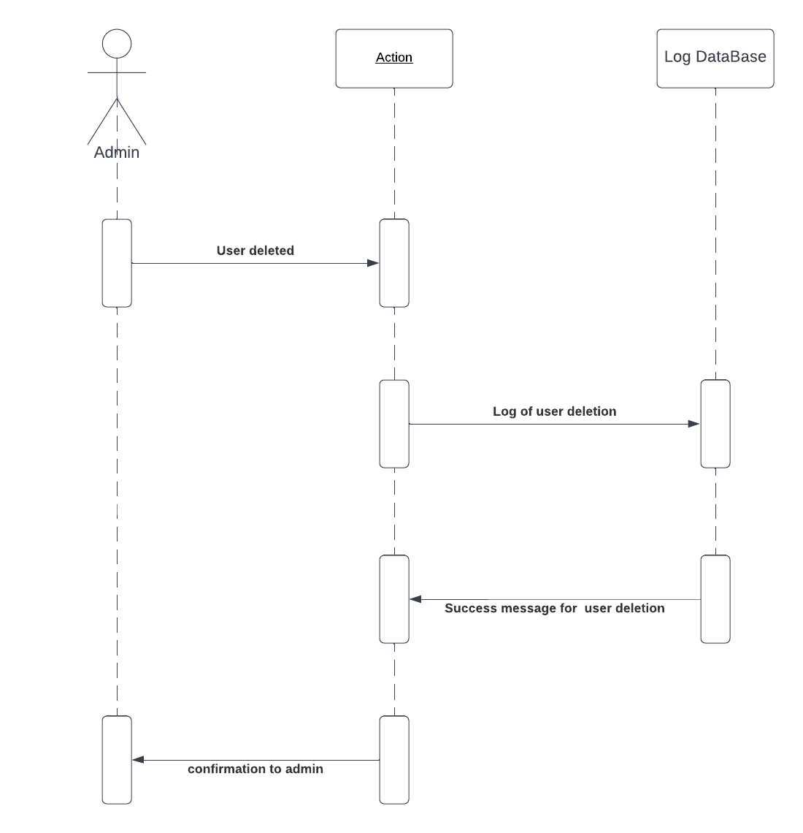

**

**POST DELETED**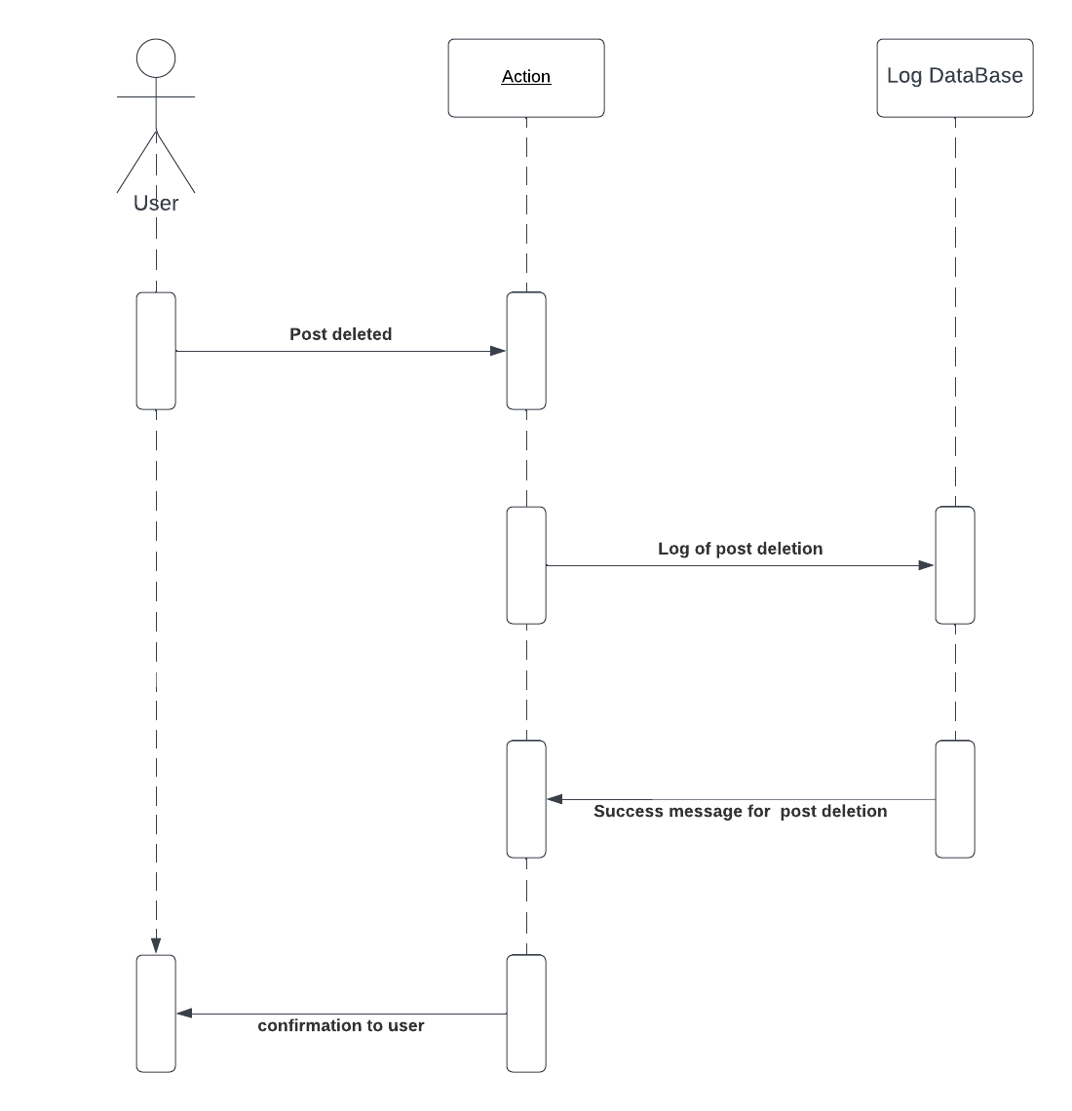

**COMMENT CREATED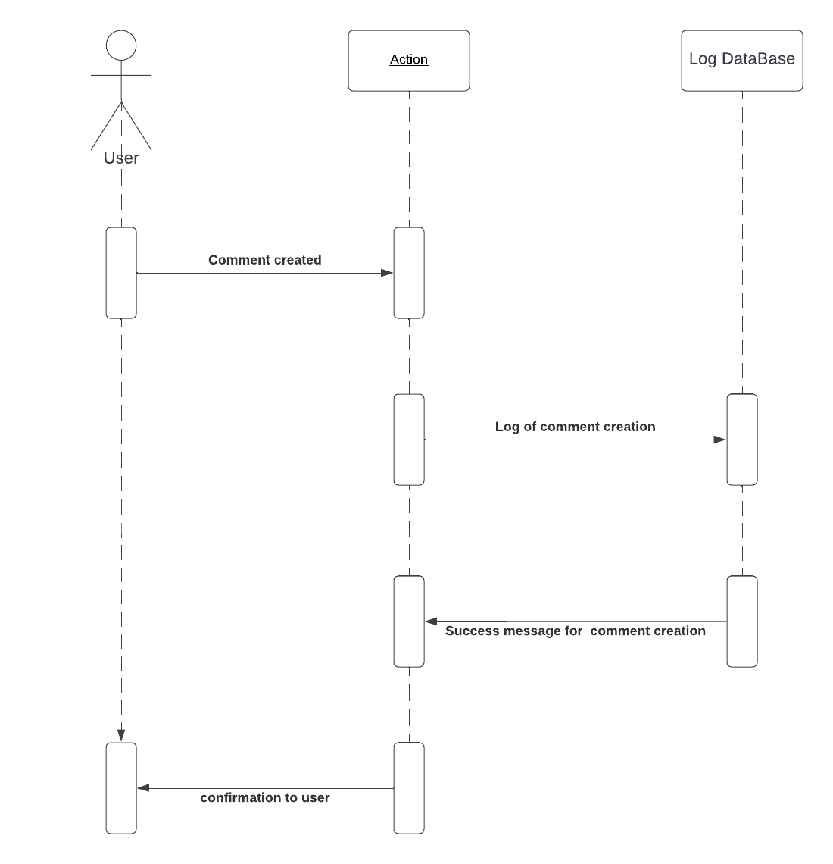COMMENT DELETED**